**HOW TO OVERCOME THE WATER CRISIS ISSUES IN PAKISTAN THROUGH SDGS FRAME WORK**

**Author: Qurat ul ain (Microbiologist)**

**University of veterinary and animal sciences**

**Co-author: Mr. Junaid Ahmad Khan (MPhil physics)**

**Riphah International University Lahore**

Pakistan is facing a severe water crisis, with significant impacts on its population, economy and environment.to overcome this crisis, its essential to address the following issue:

**WATER SCARCITY:**

water scarcity, both natural and of human origin, is the lack of sufficient available water resources to meet the demands within a region. Water is unequally distributed over time and space. Much of it is wasted, polluted and unsustainably managed.

There is no global water scarcity as such, but a number of places and regions bare chronically short of water because its use at the global level has increased more than twice as fast as the population over the last century  
pressure on water resources is increasing in several parts of the world, especially in China, India, Pakistan, in the Middle East and many countries and regions of Africa.

Pakistan has limited water resources, with a per capita availability of only 1038 cubic meters per year, compared to the global average of 2400 cubic meters. In 2020, German watch published a report that listed Pakistan as the 5th most susceptible nation to climate change.one of the several consequences of the rapidly changing climate in the country is water scarcity.

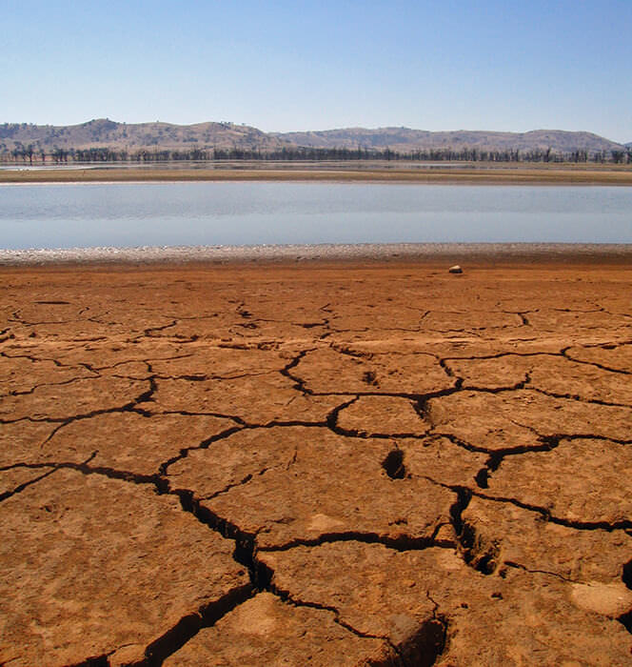 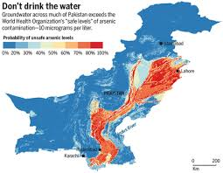

**INSUFFICIENT WATER USE:**

The agricultural sector which consumes 90% of Pakistan water often uses outdated and inefficient irrigation methods, leading to significant water waste. Based on Pakistan’s population, the country requires between 3.5 and 7 million acre-feet (MAF) of water to meet its collective domestic demand every year. The estimated range of 3.5 to 7 MAF is derived from Pakistan’s population of approximately 231 million people, each needing 50 to 100 liters water per day.

**LACK OF WATER STORAGE:**

Pakistan has limited water storage capacity with only 30 days of storage capacity compare of the global average of 120 days. Water shortages are nothing new in Pakistan. As the population and economy have grown, so has the need for water. Yet, water availability has gone in the opposite direction: a steady decrease of over 80% in 70 years.

As a result Pakistan is one of the most critically water-stressed countries in the world… and it’s only predicted to get worse.

Droughts and floods have ravaged Pakistan’s population for decades. But since the demand for water has increased along with the rate of natural disasters, Pakistan’s water shortage has become a nationwide crisis.

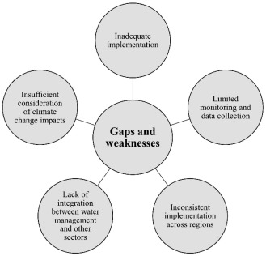

**WATER POLLUTION:**

Industrial and domestic waste contaminates Pakistan’s water sources making them unsafe for human consumption and agricultural use. Pakistan is one of the most water-polluted country in the South Asia Region. [Drinking water](https://www.sciencedirect.com/topics/earth-and-planetary-sciences/potable-water) is contaminated with microbial and toxic metals throughout Pakistan. The values of different parameters recommended by World Health Organization (WHO) are typically violated.

[Pakistan's [drinking water quality](https://www.sciencedirect.com/topics/earth-and-planetary-sciences/drinking-water-quality) is inadequately maintained and monitored, leading to threats to the health of the community. In the twenty-first century, one of the significant issues is water quantity and quality in terms of safety or pollution (Duran-Encalada et al., 2017). During the 2001 to 2020 period, the Pakistan Council of Research in Water Resources (PCRWR) reported water quality in various cities of the country. The report disclosed that almost 80 to 90% of water resource quality is below the suggested standards (PCRWR, 2021). The scarcity of clean drinking water forced people to buy alternatives in commercially available plastic water bottled. However, commercially bottled water is also not secure because it comes from not appropriately monitored plants (Water Quality, 2020). And the public cannot afford expensive water treatment systems. As a result, most Pakistanis drink polluted water, leading to various water-related diseases. Therefore, there is a need to overlook the pollution situation in Pakistan. The main goal is to spotlight the situation of water pollution in Pakistan and focus on primary sources, water pollutants, and their potential effects on human health by utilizing various researches. Moreover, this review's purpose is to make the decision-makers, policy makers, researchers, and administration departments start the valuable steps and create advanced strategies to ensure the disinfect and pure water].

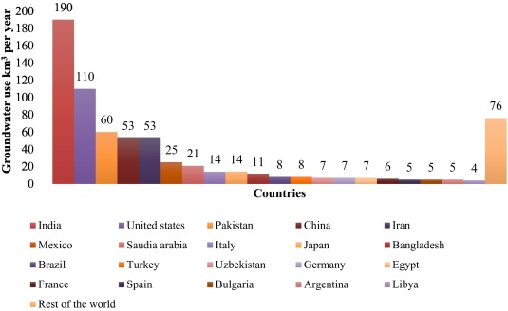

**CLIMATE CHANGE:**

climate change exacerbates Pakistan’s water crisis by altering precipitation patterns, increasing evaporation and melting glaciers.

Today, a change in climate is felt primarily though a change in water. Millions of children are at risk.

* Extreme weather events and changes in water cycle patterns are making it more difficult to access safe drinki9ng water, especially for the most vulnerable children.
* Around 74 percent of natural disasters between 2001 and 2018 were water-related, including droughts and floods. The frequency and intensity of such events are only expected to increase with climate change.
* Around 436 million children live in areas of high or extremely high water vulnerability, which is combination of water scarcity and low levels of drinking water service.
* When disasters hit, they can destroy or contaminate entire water supplies, increasing the risk of diseases like cholera and typhoid to which children are particularly vulnerable.
* Rising temperatures can lead to deadly pathogens in freshwater sources, making the water dangerous for people to drink.
* Contaminated water poses a huge threat to children’s lives. Water and sanitation related diseases are one of the leading causes of death in children under 5 year old.
* Every day, over 1000 children under 5 die from diseases linked to inadequate water, sanitation and hygiene, killing over 1.4 million people every year.
* Climate change exacerbates water stress-the ratio of total water demand to available water resources-leading to increased competition for water, even conflict.
* By 2040, almost 1 in 4 children will live in areas of extremely high water stress.
* Rising sea levels are causing fresh water to become salty, compromising the water resources millions of people rely on.

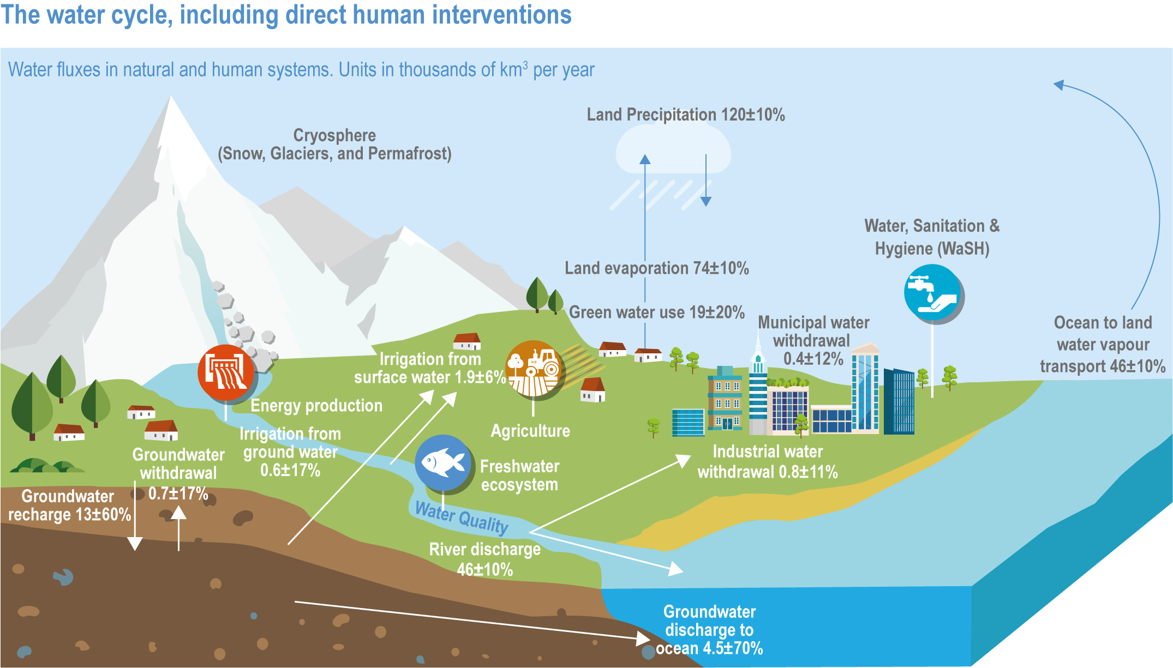

**TO OVERCOME THESE CHALLENGES, PAKISTAN CAN:**

**IMPLEMENT WATER SAVING TECHNOLOGIES:**

### Adopt efficient irrigation systems and water saving technologies in agriculture.

### Water sense labeled irrigation controllers

### Water sense labels weather-bases irrigation controllers, a type of “smart” irrigation control technology that use local weather data determine when and how much to water.water sense labeled irrigation controllers can save you water, time and money when compared to standard models



**Soil moisture sensors**

Soil moisture-bases control technologies water plants based on their needs by measuring the amount of moisture in the soil and tailoring the irrigation schedule accordingly, water sense has issues a notice of intent to label soil moisture-based control technologies.

**Rainfall shutoff device**

Rainfall shutoff device turn off your system in rainy weather and help compensate for natural rainfall. This inexpensive device can be retrofitted to almost any system.

**Rain sensors**

Rain sensors can help decrease water wasted in the landscape by turning off the irrigation system when it raining.

**Sprinkler heads**

Certain types of sprinkler heads apply water more efficiently than others. Rotary spray heads deliver water in a thicker stream than mist spray heads, ensuring more water reaches plants and less is lost to evaporation and wind. Water sense has issued a notice of intent to label landscape irrigation sprinklers.

**Micro irrigation**

Micro-irrigation or drip systems are generally more efficient than conventional sprinklers, because they deliver low volumes of water directly to plants roots minimizing losses to wind, runoff, evaporation, or overspray drip irrigations systems use 20 to 50 percent less water than conventional prop-up sprinklers systems and can save up to 30,000 gallons per year. Consider installing drip around trees, shrubs and gardens in place of a conventional sprinklers system.

**ENHANCE WATER STORAGE:**

Invest in building new dams, reservoirs and water storage infrastructure.



**PROMOTE WATER CONSERVATION:**

Educate the public about water conservation and implement measures to reduce water waste.

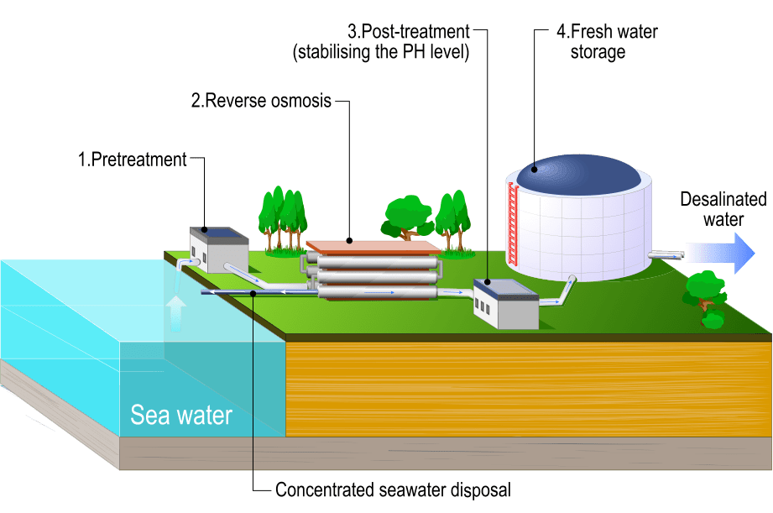

**PROTECT WATER SOURCES:**

Implement effective waste water treatment and pollution control measures to protect water sources.

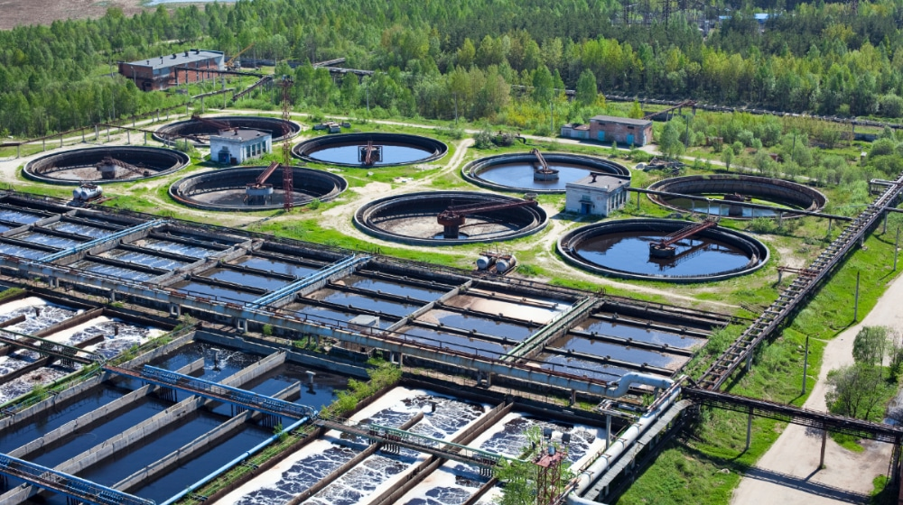

**DEVELOP CLIMATE RESILIENT WATER MANAGEMENT:**

Integrate climate change adaptation strategies into water management practices.

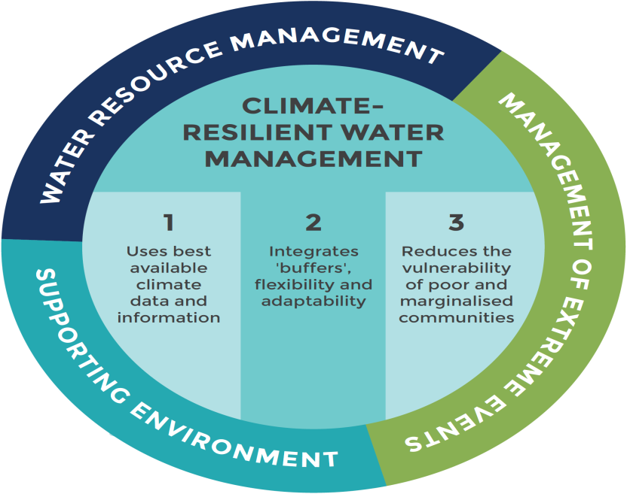

**TO ADDRESS THIS CRISIS, THE UNITED NATIONS SUSTAINABLE DEVELOPMENT GOALS SDGS, OFFER A COMPREHENSIVE FRAMEWORK.**

**SDG 6: CLEAN WATER AND SANITATION**

Ensure universal access to safe and affordable drinking water

Improve water quality and waste water management

Increase water efficiency and reduce scarcity

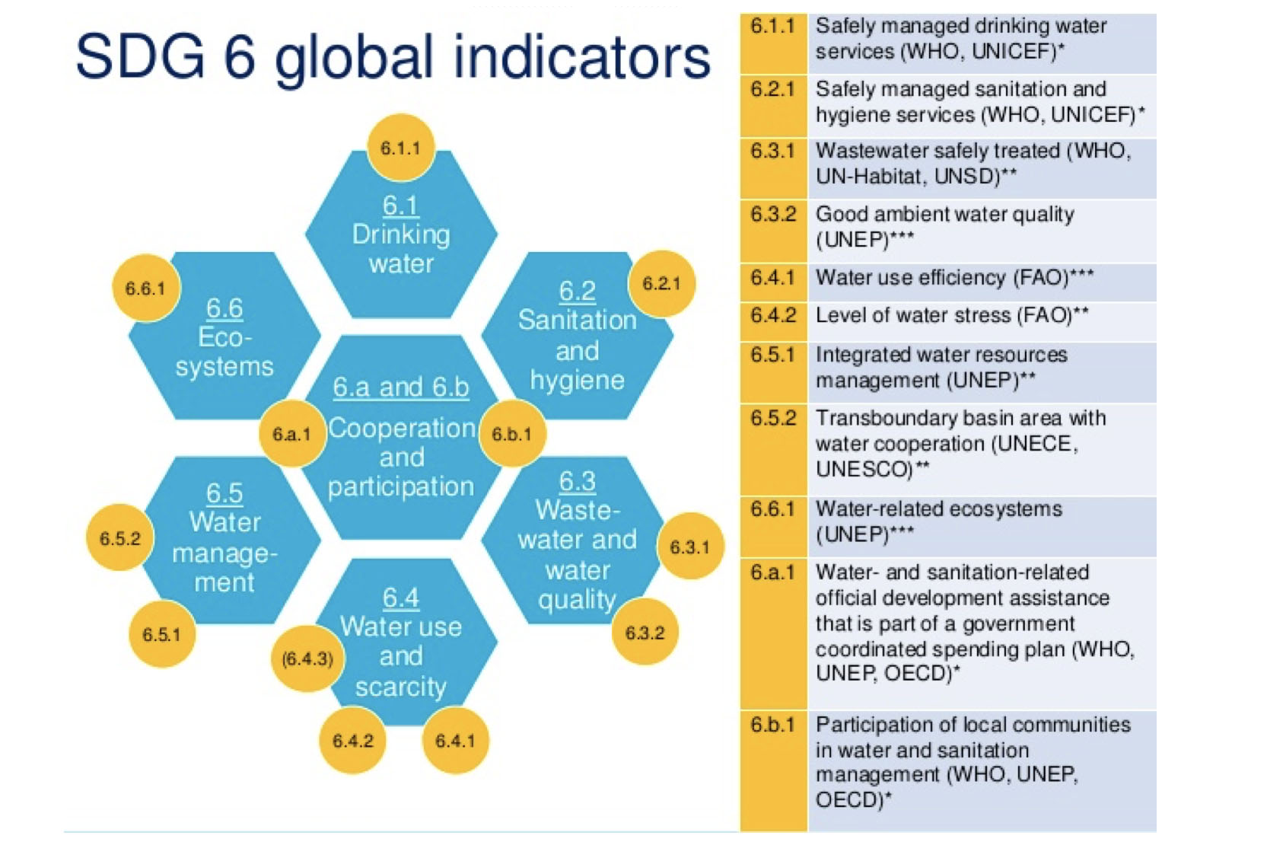

**SDG 13: CLIMATE ACTION**

Address climate change impacts on water resources

Promote water adaptation and resilient measures

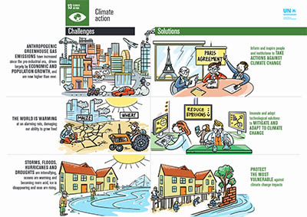

**SDG 15: LIFE ON LAND**

Protect and restore water related ecosystems

Promote sustainable land use and water management practices

Space technologies play a central role in:

* Climate change monitoring
* Weather forecasting
* Disaster management
* Search and rescue operations



**SDG 17: PARTNERSHIP FOR THE GOALS**

Foster international cooperation and partnerships for water management

Encourage knowledge sharing and capacity building

**By aligning efforts with these SDGs Pakistan can:**

* Develop integrated water resources management plans
* Invest in water infrastructure and efficient technologies
* Promote water conservation and awareness
* Enhance water governance and institutions
* Encourage trans-boundary water cooperation

**INITIATIVES TAKEN BY PAKISTAN WATER RESOURCE DEPARTMENT FOR WATER STORAGE AND CONSERVATION AT NATIONAL LEVEL BY 2024,**

One of the key initiatives is the National water policy, which was released by the Ministry of Water Resources in April 2018,

The policy aims to promote the sustainable use of water resources and maximize crop yield per water unit.

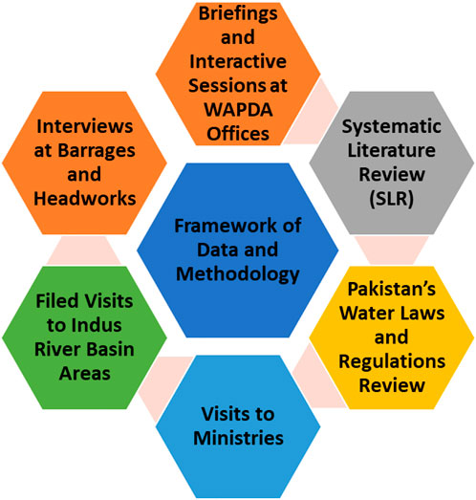

**NATIONAL WATER POLICY 2018:**

This policy identified priorities for groundwater management emphasizing the need to curb groundwater over abstraction and contamination.

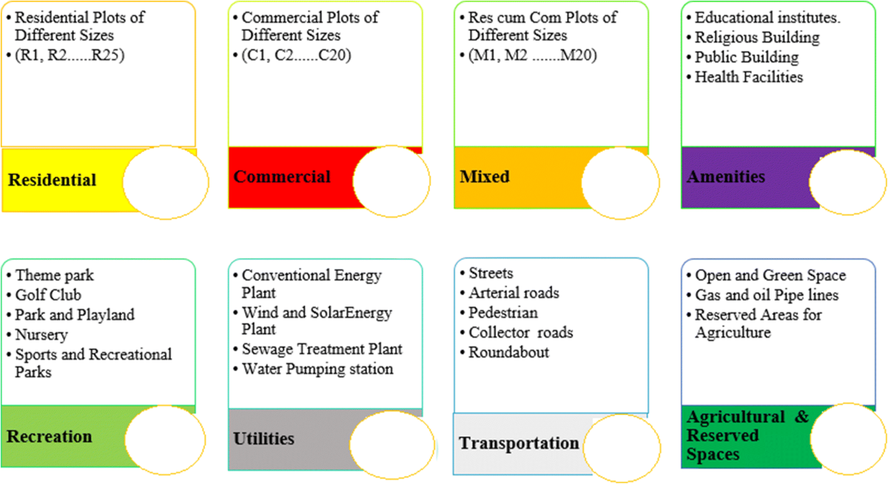

**PUNJAB WATER POLICY 2018:**

This policy built upon the National water policy, focusing on improving groundwater management in Punjab province

**PUNJAB WATER ACT IN 2019:**

This act established a regime of licenses for abstraction and wastewater disposal, managed by newly created regulatory bodies.

**PUNJAB RURAL SUSTAINABLE WATER SUPPLY AND SANITATION PROJECT (PRSWSSP):**

This project approved in 2021 aims to upgrade water supply and sanitation infrastructure and service in rural Punjab, ensuring equitable and sustainable access to drinking water and safe waste water management.

For each of the sectors (Agriculture, Domestic and Industrial) strategic objectives for water conservation are developed. For agriculture these include, among other things, introducing of pricing policy (also for the other sectors), development of non-conventional water sources for agriculture (secondary treated sewage water, drainage effluent, rainwater, saline effluent, seawater) and undertaking watershed management. For the domestic sector, measures include, among other things, formulating and enforce Zero Liquid Discharge (ZLD) Policy (also for industrial use), development of water metering systems and conducting of water audits. The implementation framework for this strategy will require public and private partnerships with lead and supportive roles assigned to different agencies/institutions to ensure a coordinated implementation of the strategy with all the relevant departments/agencies and other relevant actors.

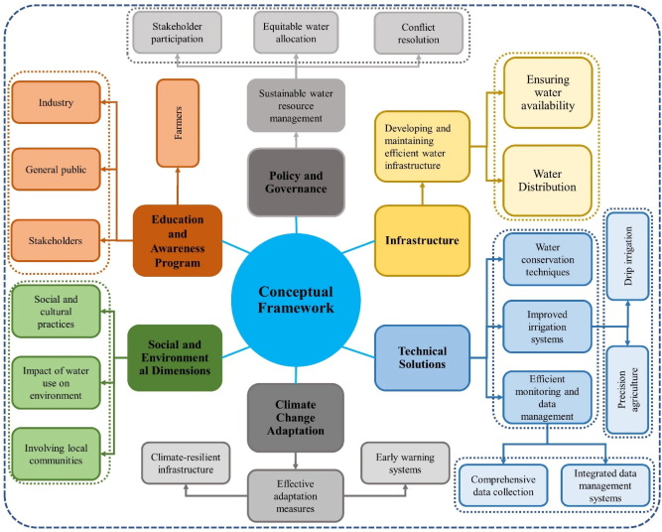

**CALL DO ACTION:**

The potential options to overcome these issues include:

1. Construction of small and large dams where possible. improving the surface water governance with proper pricing
2. legislating and restricting indiscriminate groundwater abstraction
3. controlling increase in population

The data used in this article is taken from different articles after a comprehensive review. All articles reffrences after mentioned in tables. The data of major pollutants were collected from 2000 to 2020.. Overall the whole Pakistan data is used in this review. But for maps, all major cities are considered i.e., Peshawar, Lahore, Islamabad, Rawalpindi, Bahawalpur, Faisalabad, Gujranwala, Gujrat, Kasur, Multan, Sheikhupura, Sargodha, Sialkot, Sukkur etc.

**References**

<https://www.waterforpeople.org/our-strategy/?gad_source=1&gclid=EAIaIQobChMI8-X4ybuOiAMVd6lmAh1T5B6fEAAYASAAEgJmoPD_BwE>

<https://pcrwr.gov.pk/wp-content/uploads/2021/07/Water-Scarcity-in-Pakistan-Issues-and-Options-May-18.pdf>

<https://www.worldwildlife.org/threats/water-scarcity/>

<https://www.unicef.org/wash/water-scarcity>

<https://www.sciencedirect.com/topics/earth-and-planetary-sciences/water-scarcity>

<https://pide.org.pk/research/water-crisis-in-pakistan-manifestation-causes-and-the-way-forward/>

<https://www.googleadservices.com/pagead/aclk?sa=L&ai=DChcSEwjTu9f7vI6IAxX_g0sFHYaKDocYABAAGgJzZg&co=1&ase=2&gclid=EAIaIQobChMI07vX-7yOiAMV_4NLBR2Gig6HEAAYASAAEgL1QvD_BwE&ohost=www.google.com&cid=CAASJuRo3xBj7cRSa2UfF-oRPdt2ja_xLIQ7NjBkTwJ6JZtWq76f9CQe&sig=AOD64_32R5RcZUrSU1LhXnUV-cGz5E54Dg&q&nis=4&adurl&ved=2ahUKEwiChdT7vI6IAxWx-aACHRzgEHAQ0Qx6BAgVEAE>

<https://www.nationalgeographic.org/article/sustainable-development-goals/>